Worked Example 1: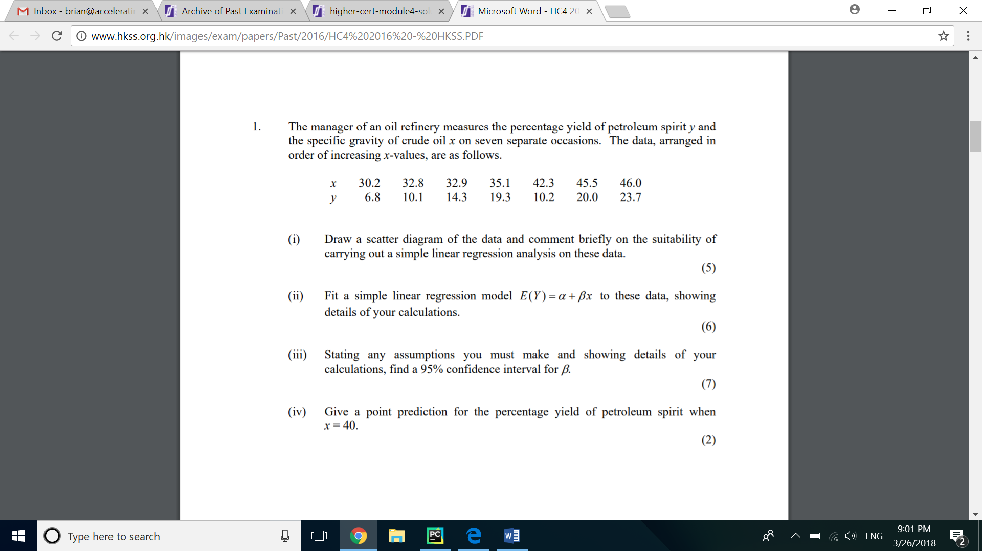

Worked Example 2:

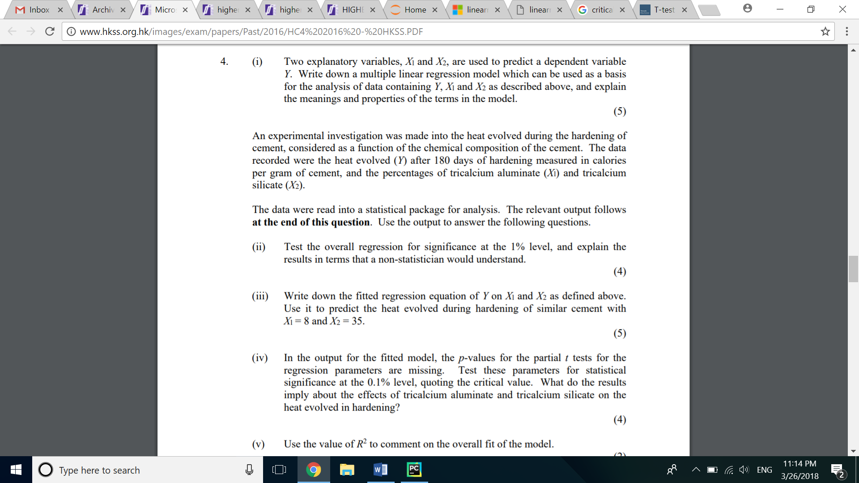

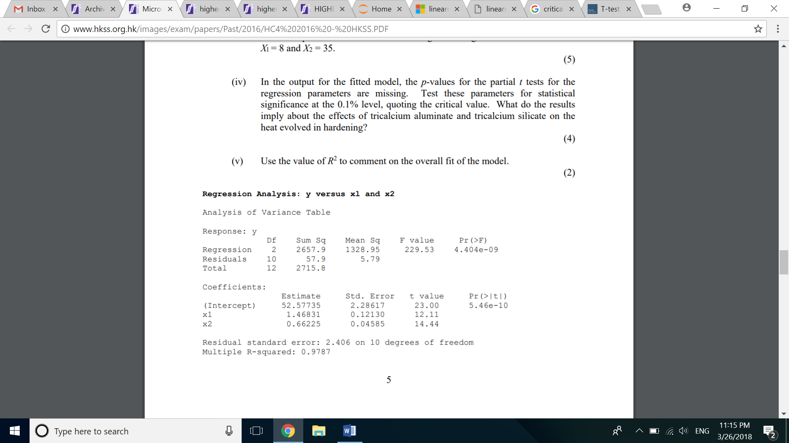

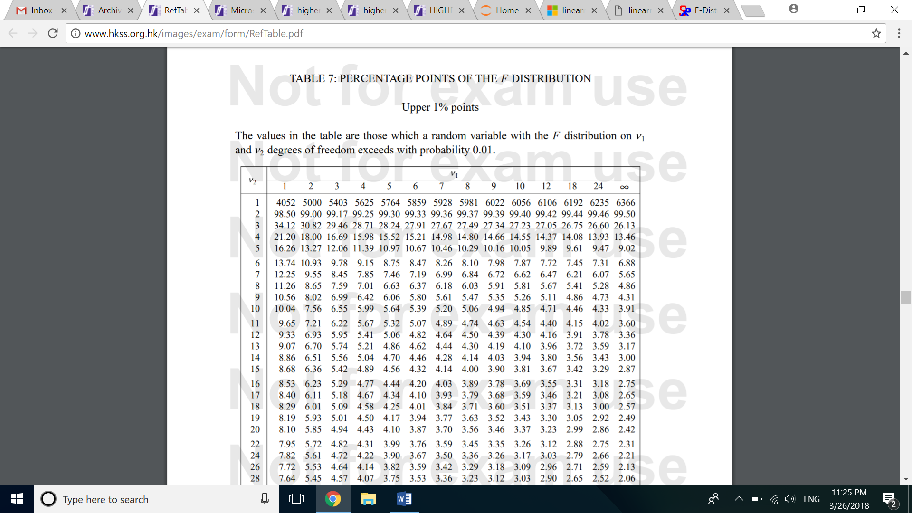

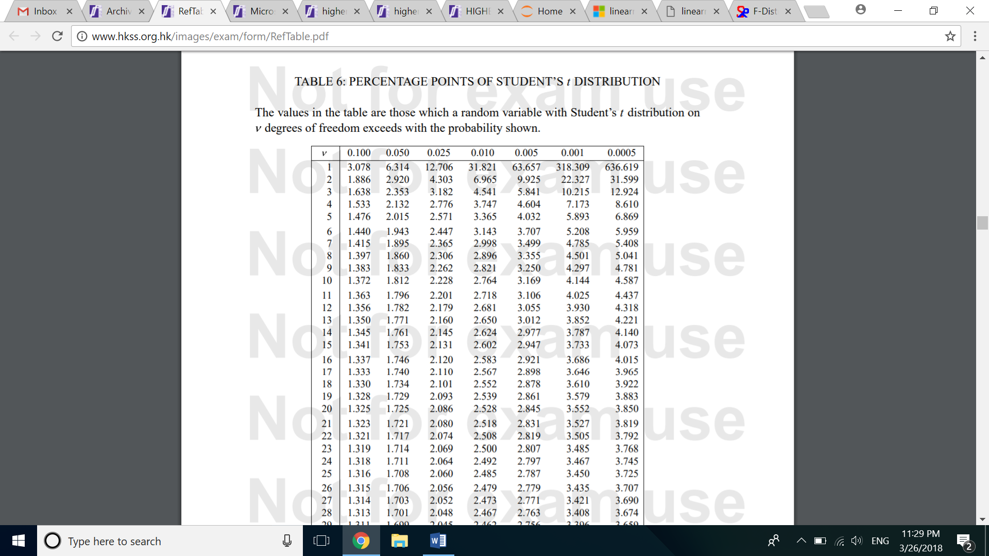

Exercise 1:

With reference the simple linear model and multiple linear model in the above examples and the proof of the mathematics behind, answer (iii) and (iv) with Python script

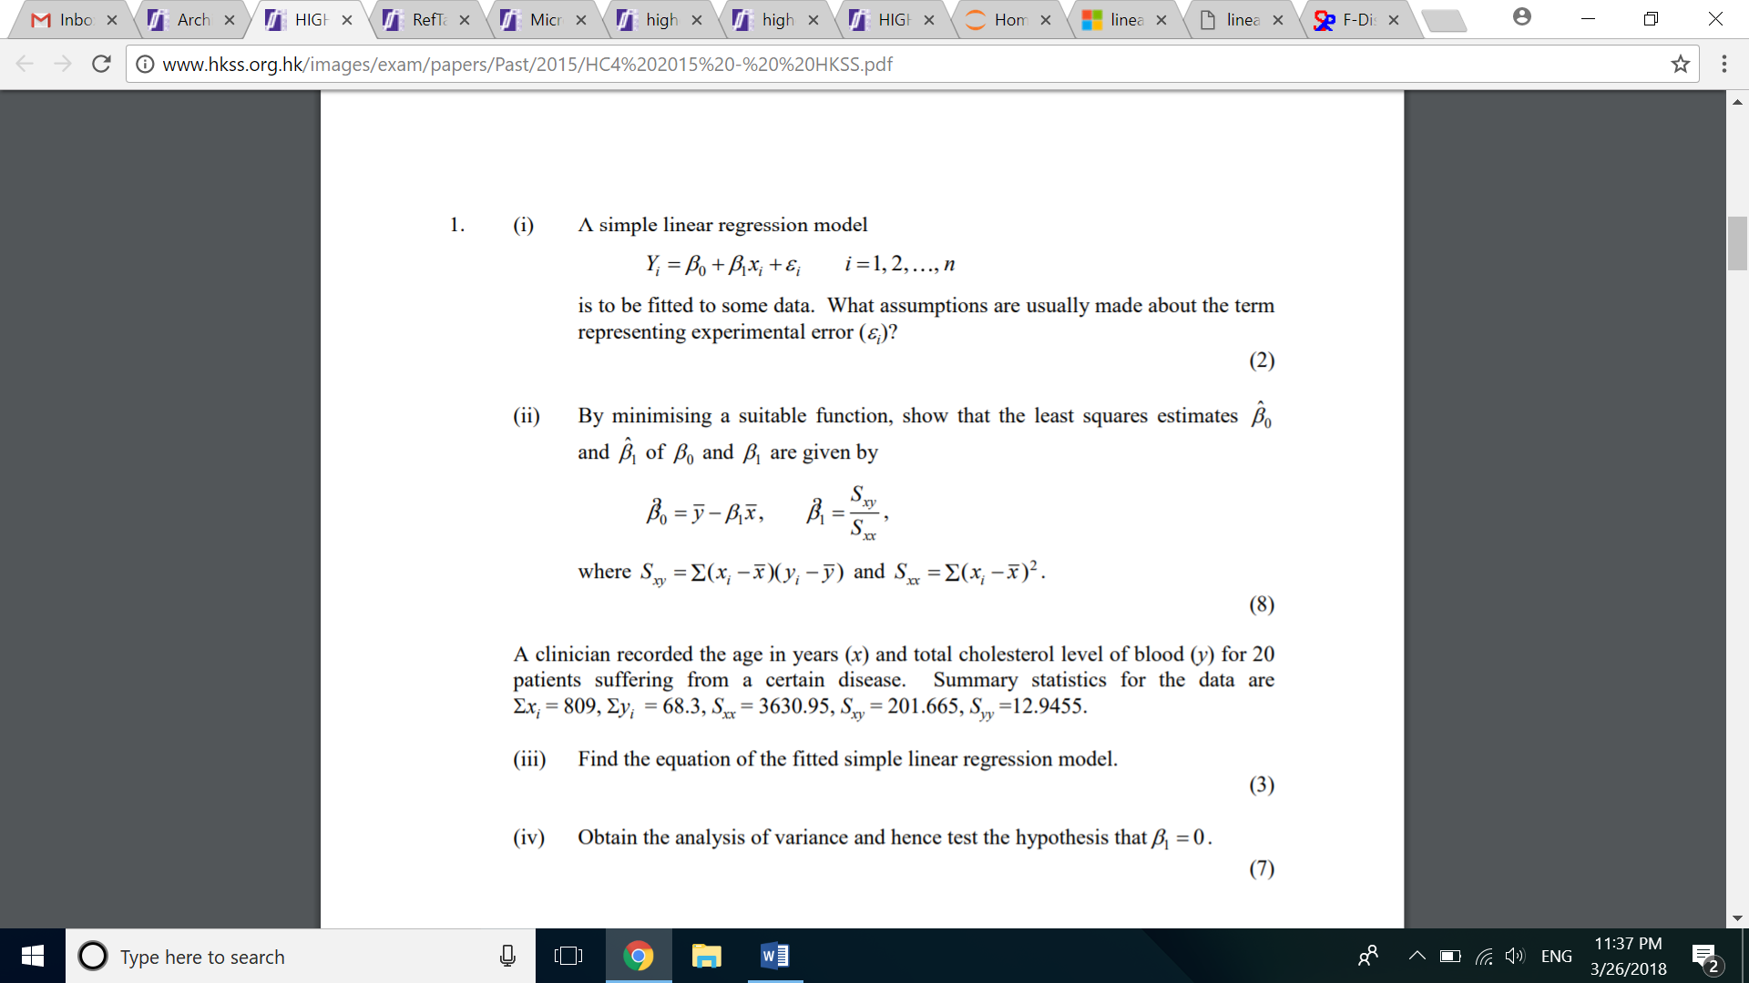

Reference:

<http://www.hkss.org.hk/images/exam/papers/Past/2015/HC4%202015%20-%20%20HKSS.pdf>

Exercise 2:

By making use of Python, translate the following scientific question that can be solved in Python

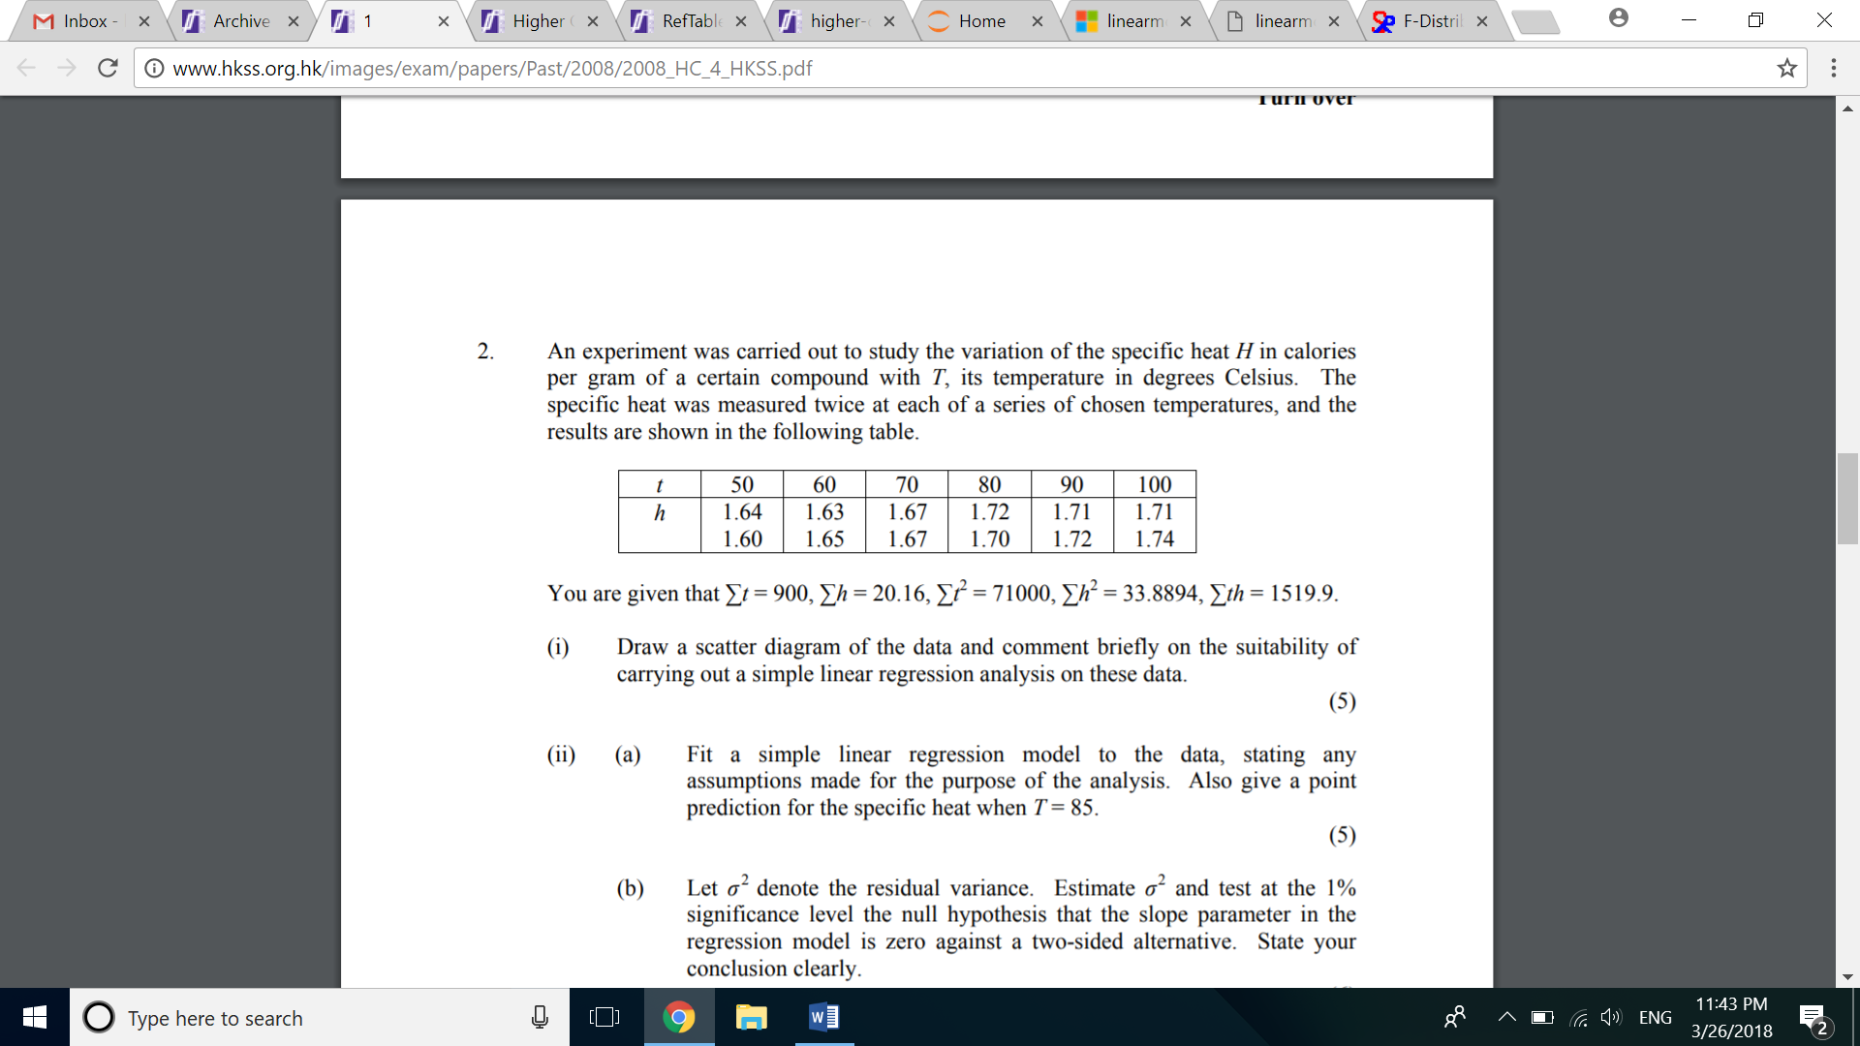

Reference:

<http://www.hkss.org.hk/images/exam/papers/Past/2008/2008_HC_4_HKSS.pdf>

Exercise 3: Under the commercial situation below, formulate multiple linear model by Python and interpret the result to non-statistician

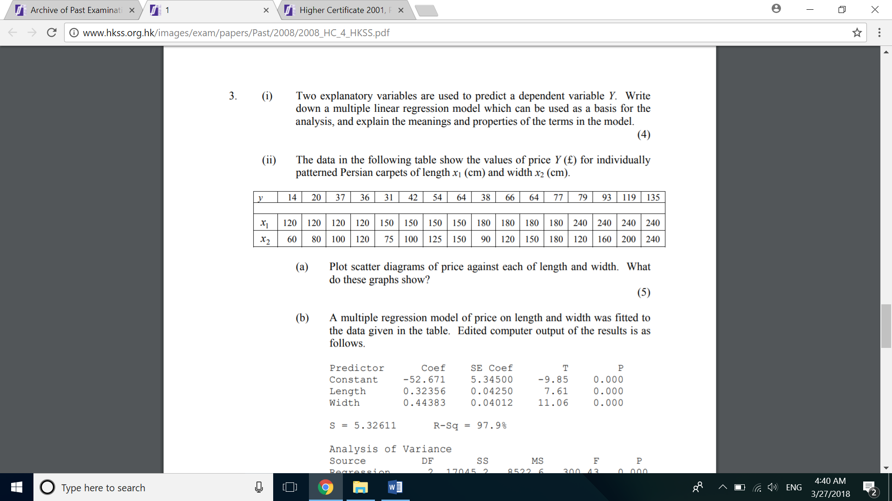

You should be able to get the following information that support your explanation to other audience

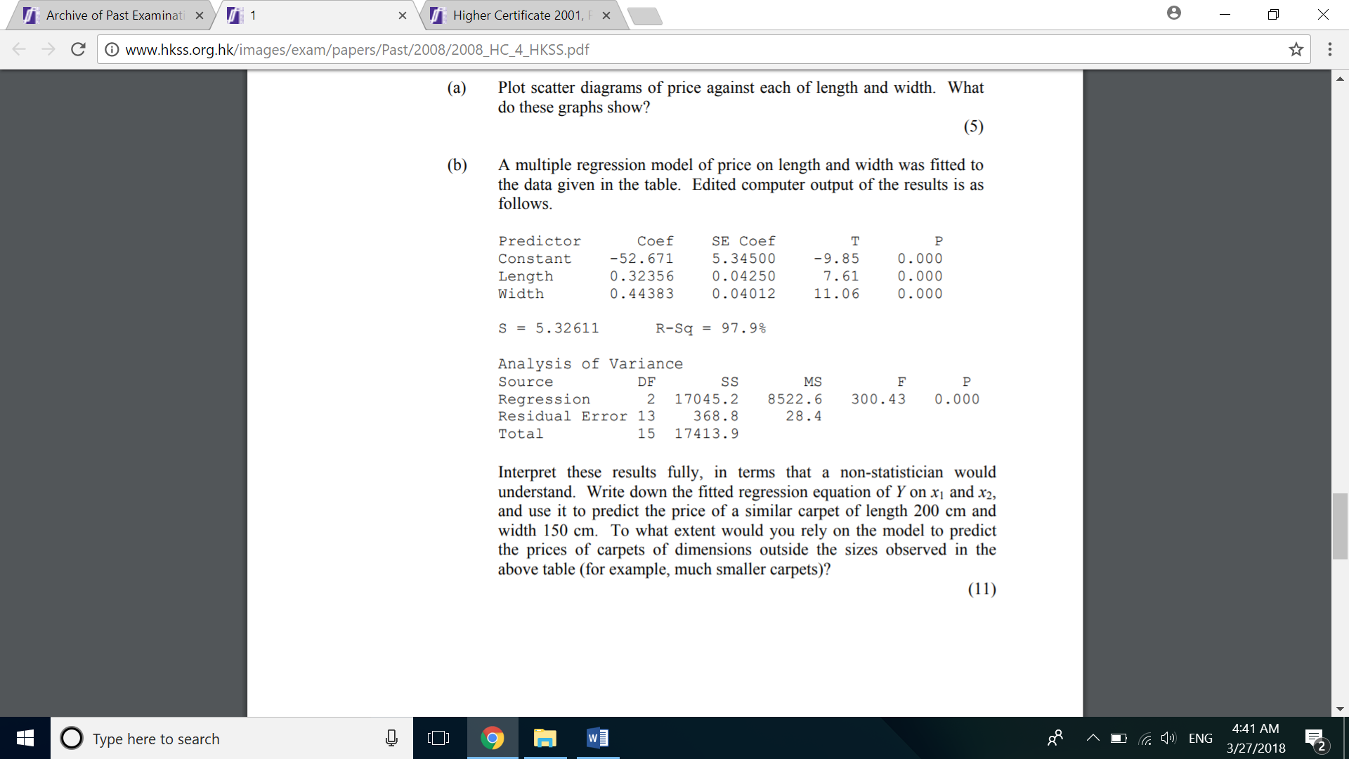

Reference:

<http://www.hkss.org.hk/images/exam/papers/Past/2008/2008_HC_4_HKSS.pdf>

Exercise 4:

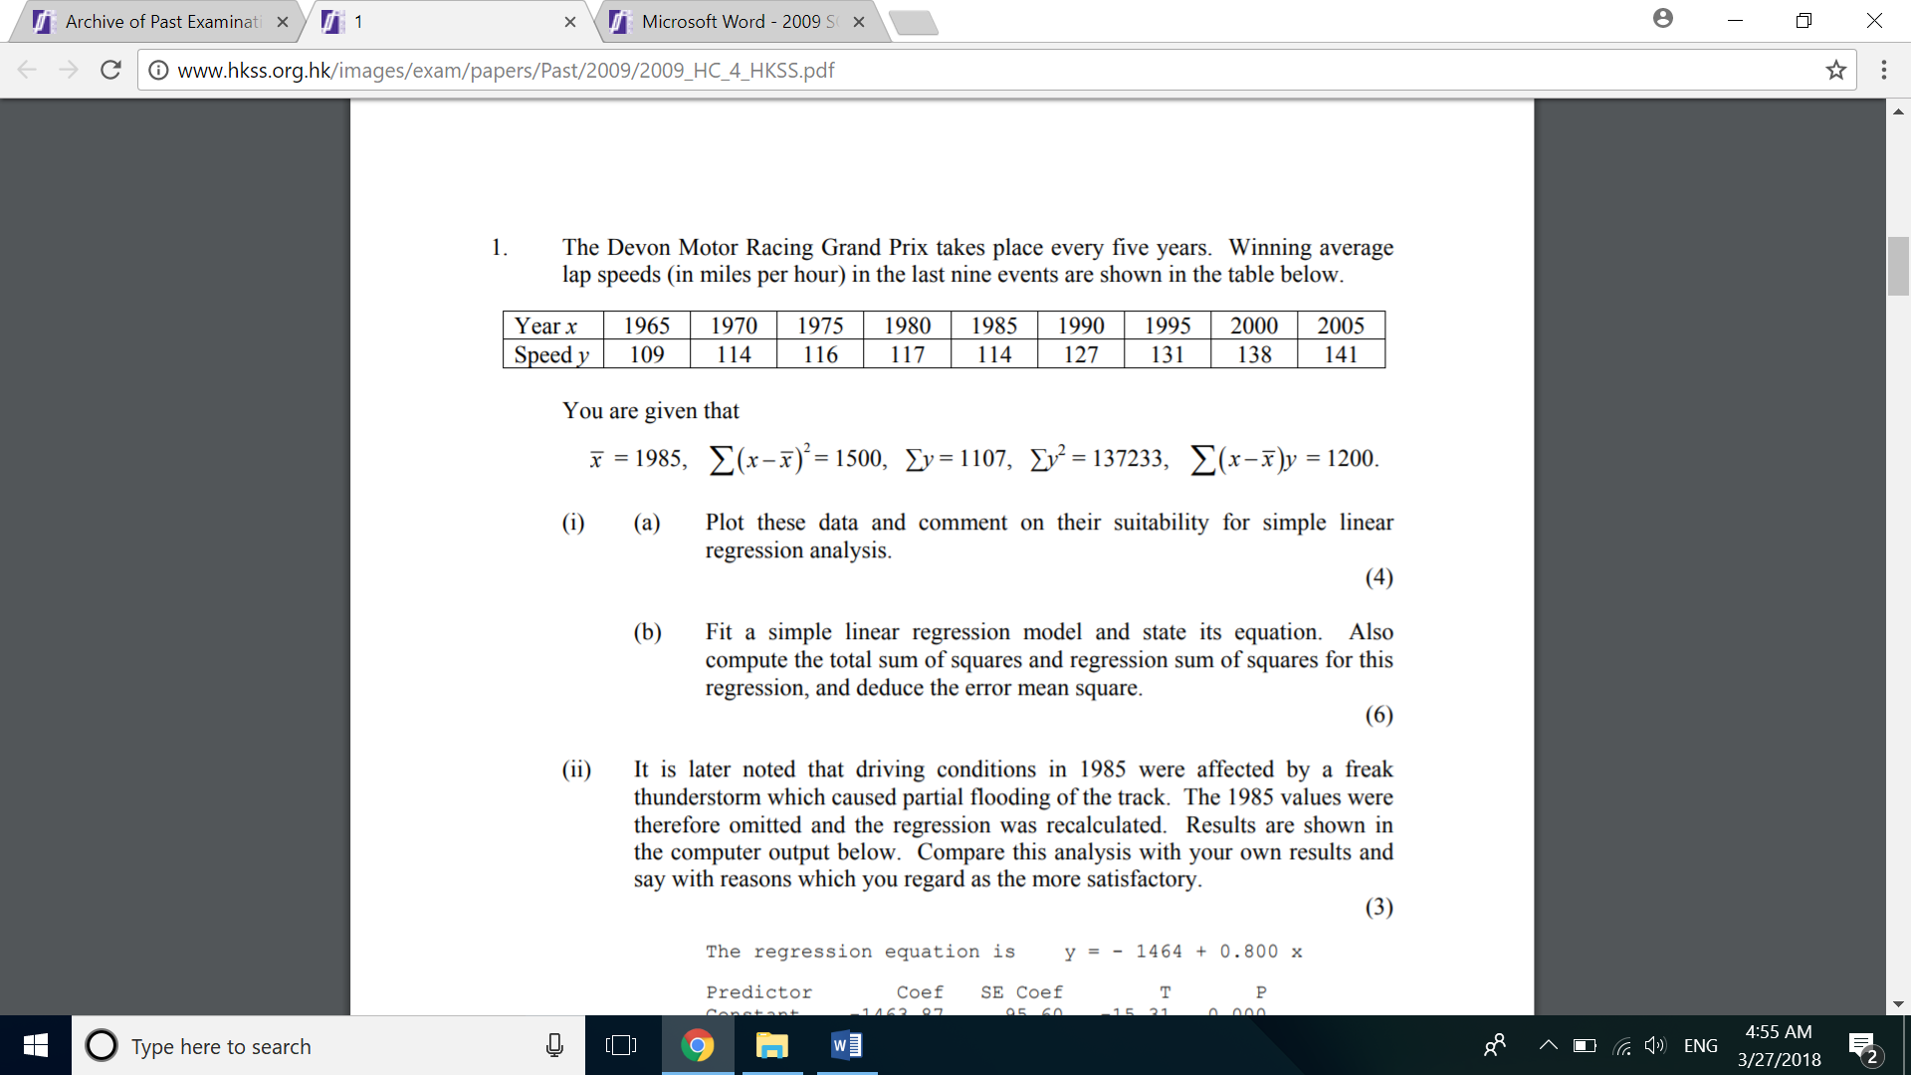

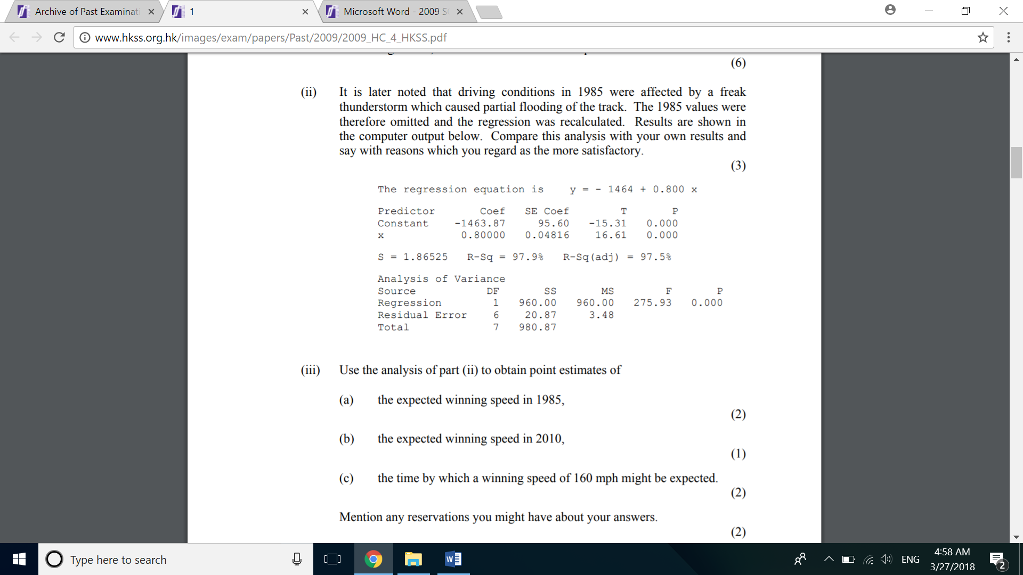

Reference:

<http://www.hkss.org.hk/images/exam/papers/Past/2009/2009_HC_4_HKSS.pdf>

Exercise 5:

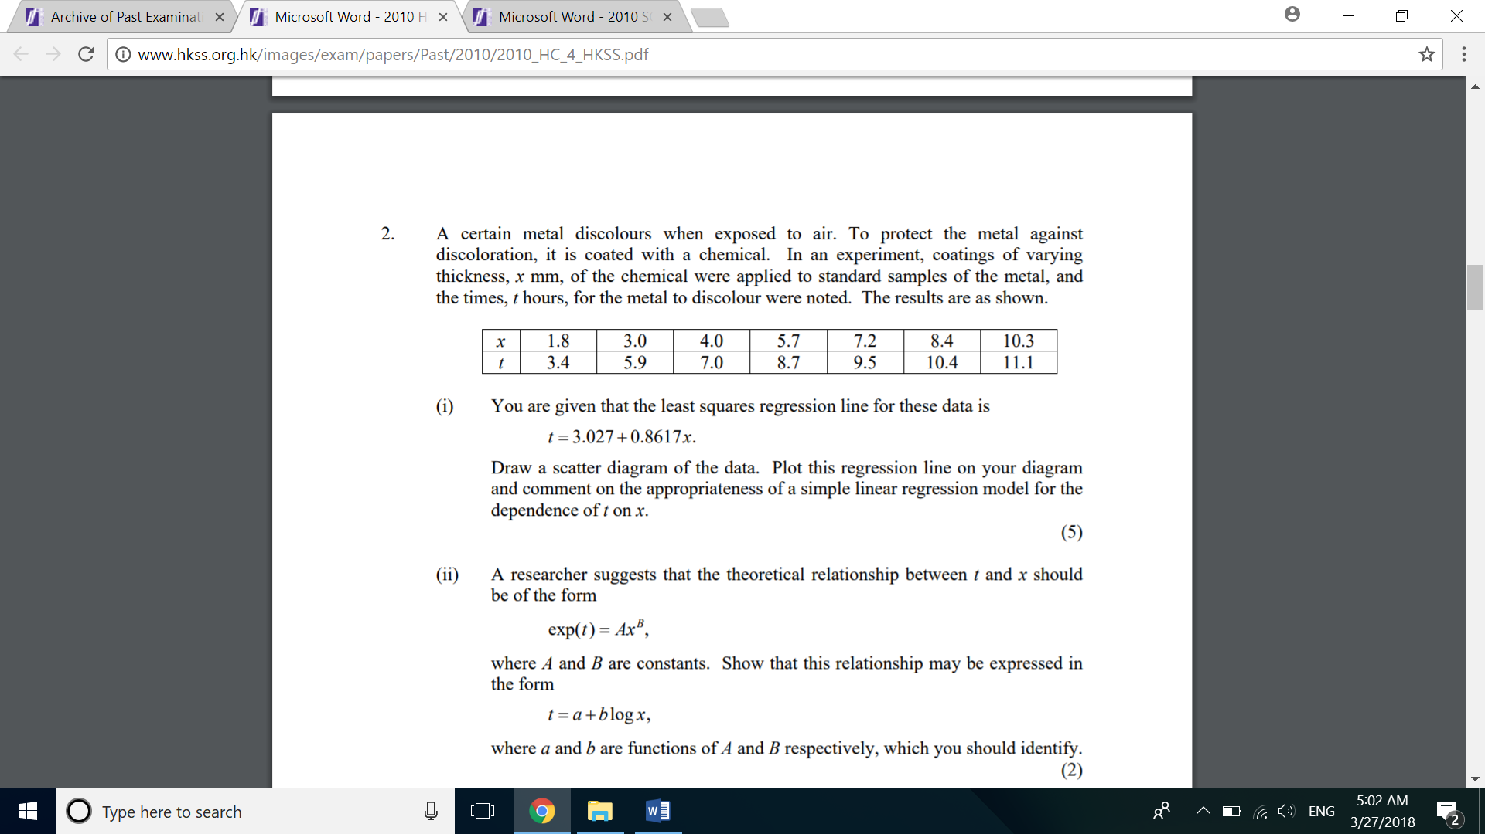

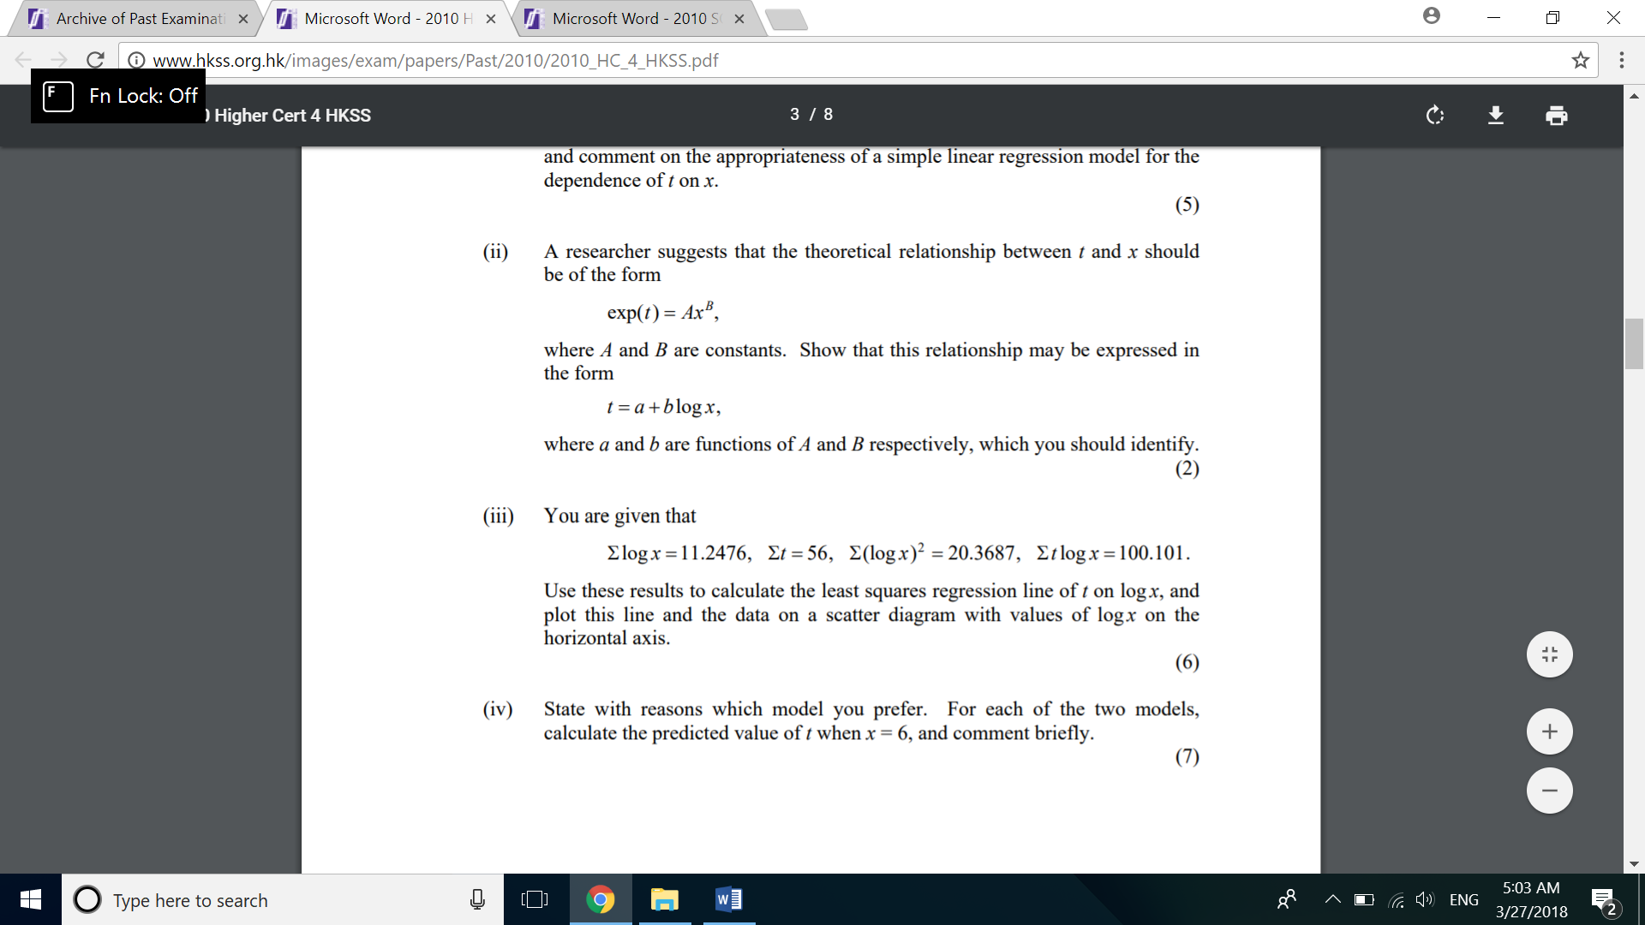

Reference:

<http://www.hkss.org.hk/images/exam/papers/Past/2010/2010_HC_4_HKSS.pdf>

Revision Exercise on hypothesis testing:

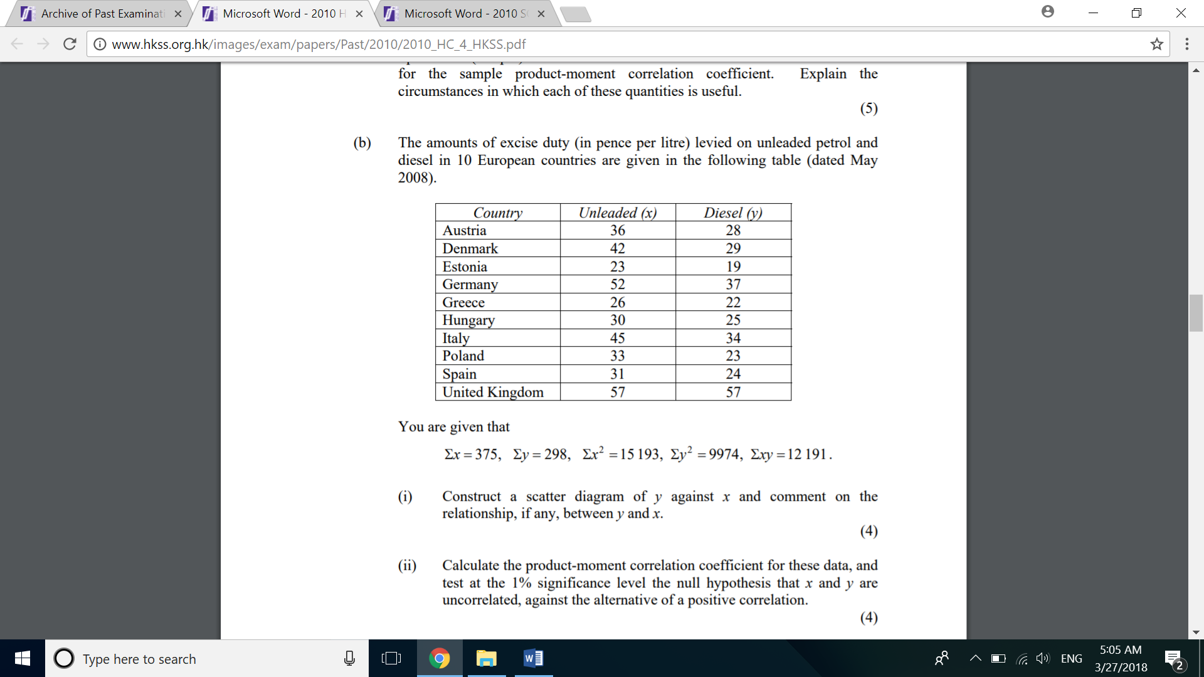

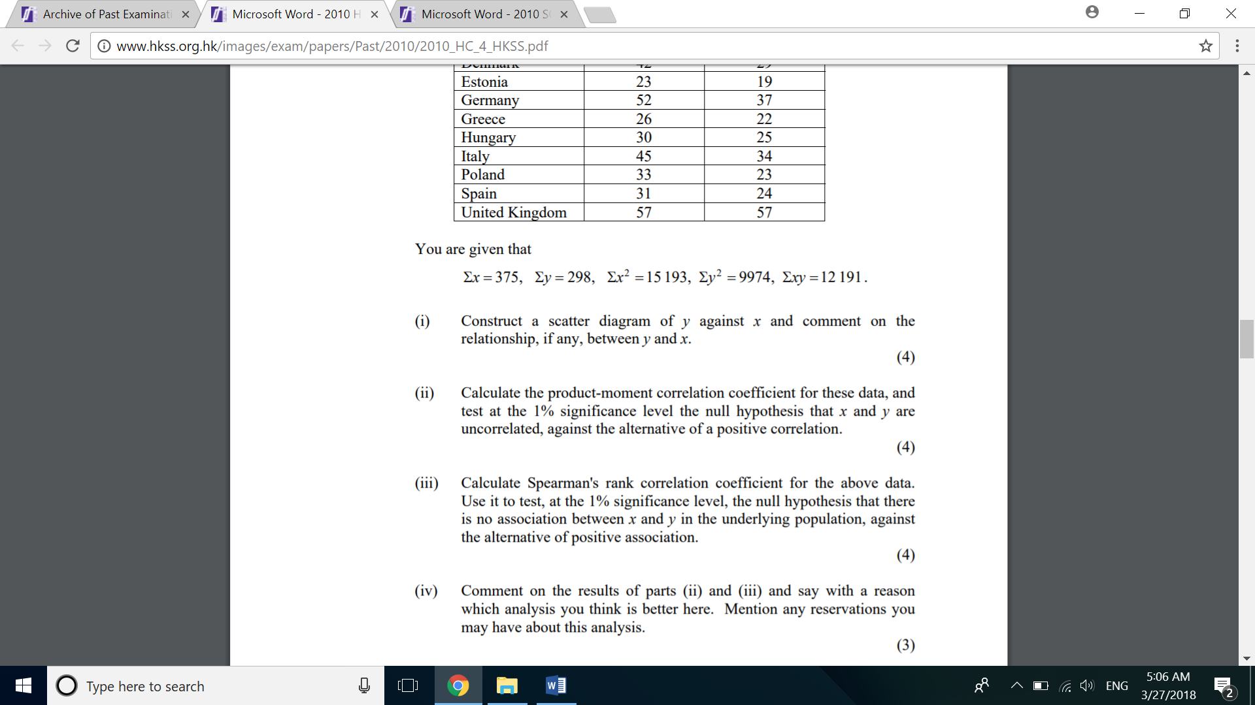

Reference:

<http://www.hkss.org.hk/images/exam/papers/Past/2010/2010_HC_4_HKSS.pdf>

Revision Exercise on hypothesis testing:

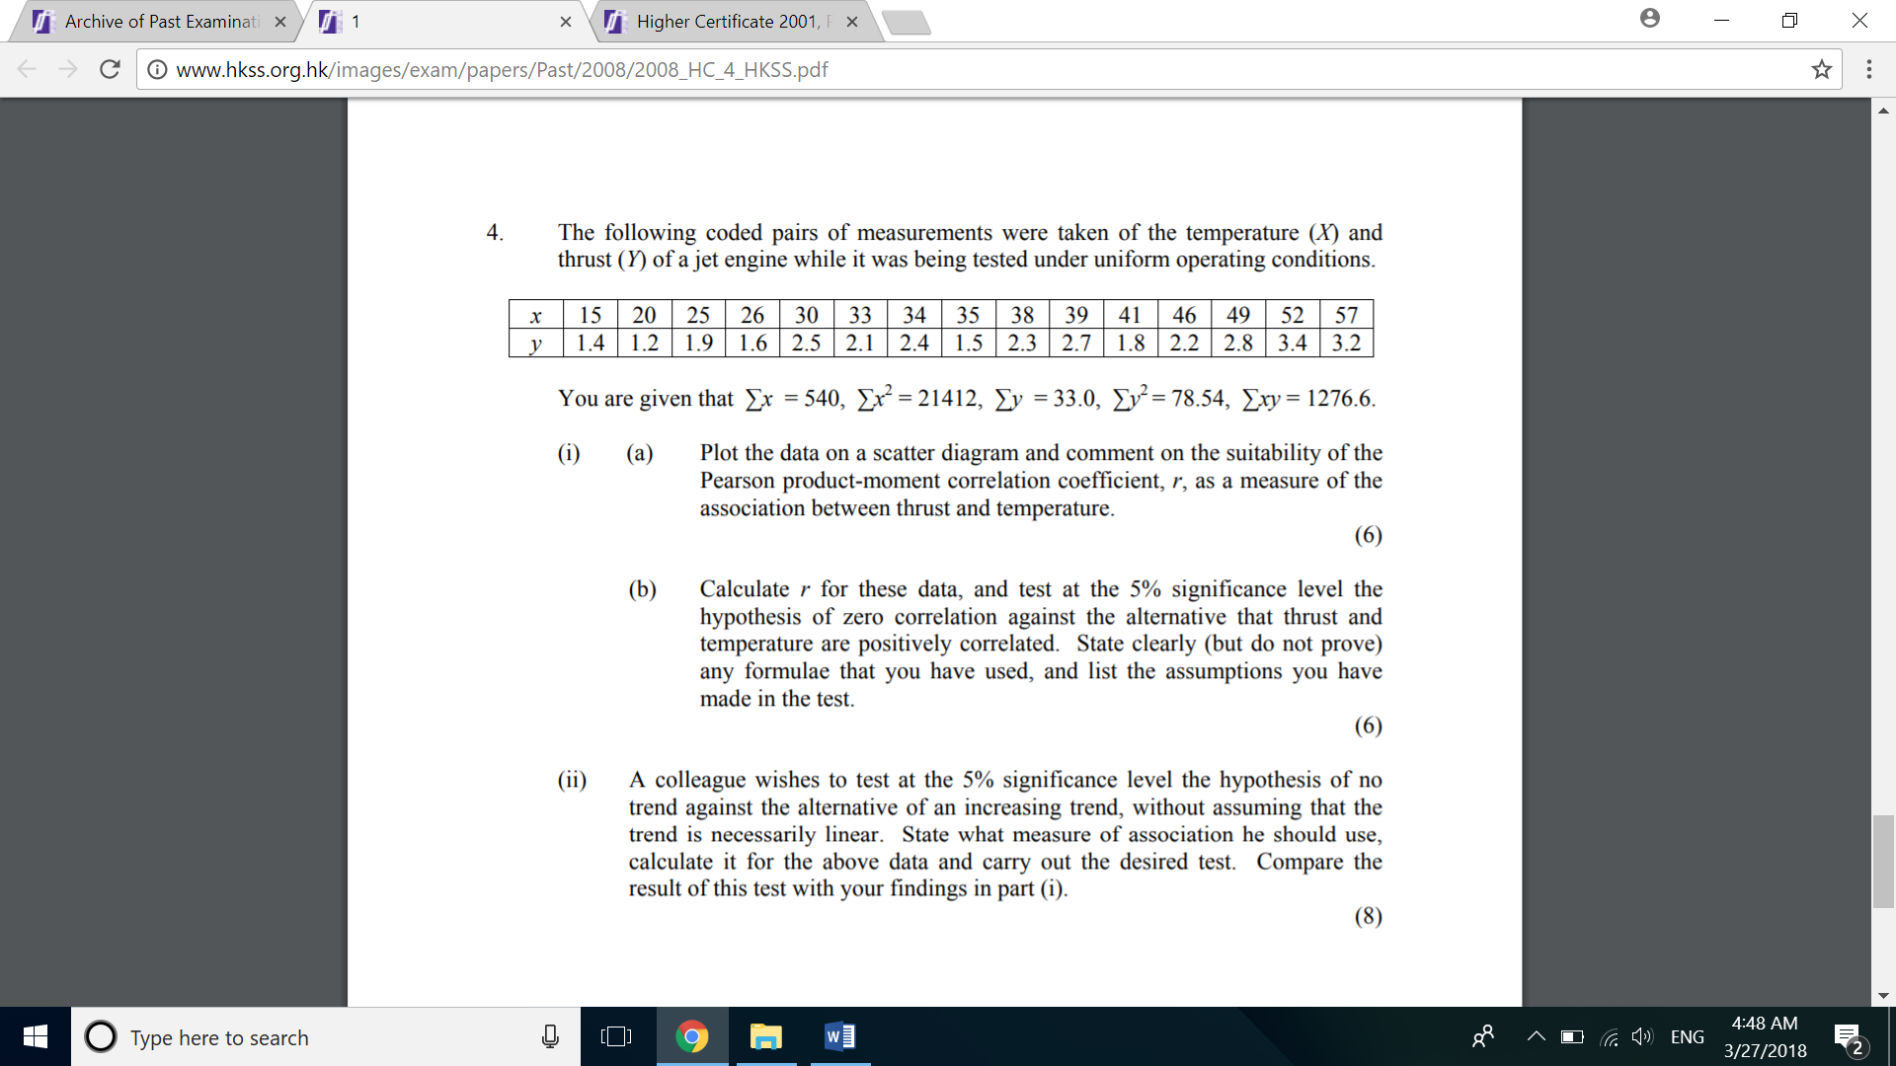

Reference:

<http://www.hkss.org.hk/images/exam/papers/Past/2008/2008_HC_4_HKSS.pdf>